## **Objectives**

* Explain React components
* Identify the differences between components and JavaScript functions
* Identify the types of components
* Explain class component
* Explain function component
* Define component constructor
* Define render() function

In this hands-on lab, you will learn how to:

* Create a function component
* Apply style to components
* Render a component

## **Prerequisites**

The following is required to complete this hands-on lab:

* Node.js
* NPM
* Visual Studio Code

## **Notes**

Estimated time to complete this lab: **30 minutes.**

Create a react app for Student Management Portal named scorecalculatorapp and create a function component named “CalculateScore” which will accept Name, School, Total and goal in order to calculate the average score of a student and display the same.

1. Create a React project named “scorecalculatorapp” type the following command in terminal of Visual studio:



1. Create a new folder under Src folder with the name “Components”. Add a new file named “CalculateScore.js”
2. Type the following code in CalculateScore.js

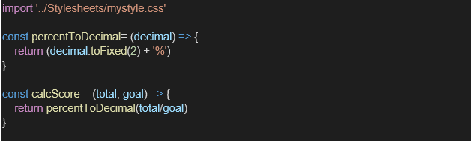

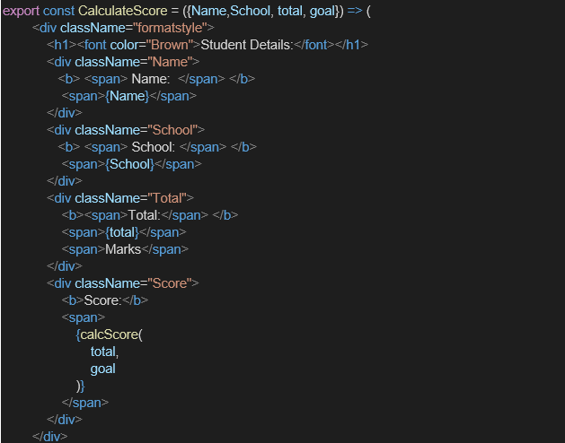

1. Create a Folder named Stylesheets and add a file named “mystyle.css” in order to add some styles to the components:

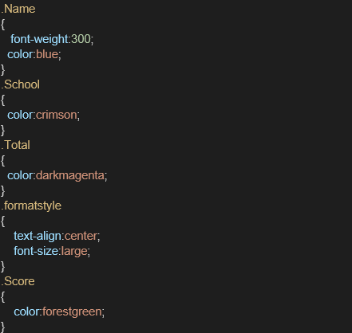

1. Edit the App.js to invoke the CalculateScore functional component as follows:

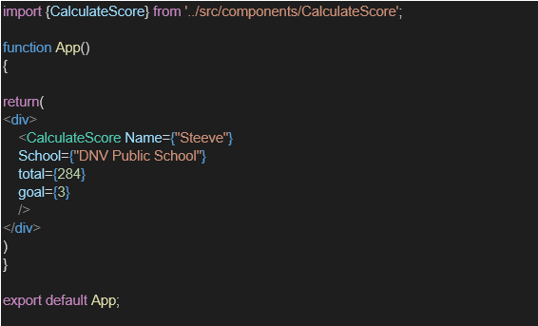

1. In command Prompt, navigate into scorecalculatorapp and execute the code by typing the following command:



1. Open browser and type “localhost:3000” in the address bar:

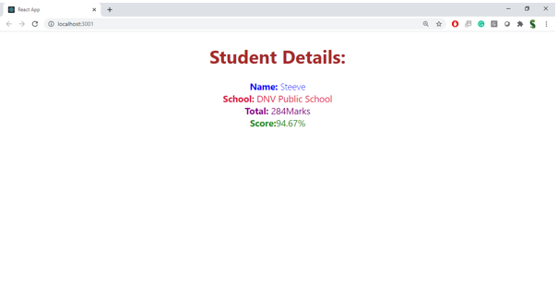

CalculateScore.js

import React from 'react';

import '../Stylesheets/mystyle.css';

function CalculateScore(props) {

const { name, school, total, goal } = props;

const average = total / goal;

return (

<div className="score-card">

<h2>Student Score Details</h2>

<p><strong>Name:</strong> {name}</p>

<p><strong>School:</strong> {school}</p>

<p><strong>Total Score:</strong> {total}</p>

<p><strong>Goal:</strong> {goal}</p>

<p><strong>Average Score:</strong> {average.toFixed(2)}</p>

</div>

);

}

export default CalculateScore;

mystyle.css

.score-card {

border: 2px solid #007bff;

padding: 20px;

margin: 30px;

border-radius: 10px;

background-color: #f0f8ff;

font-family: Arial, sans-serif;

}

.score-card h2 {

color: #007bff;

}